**Lab <lab number> <lab title>**

**Primary Objectives**

1. Design (example)

2. Implementation (example)

3. Testing (example)

*Objective 1 Design*

Figure 1 shows an example figure. The figure has been captioned with a number denoting its place in the document relative to other figures as well as a title.



Figure Example Figure

*Objective 2 Implementation*

Figure 2 shows an example of a logisim implementation. In the figure we can see that everything is clearly labeled and is easy to digest.

Figure Example Implementation

*Objective 3 Testing*

Table 1 shows an example of a test log that contains testing data for the implementation in Figure 2. On its own it is somewhat difficult to understand what is happening. A description of some sort will become necessary with complex designs.

Table Example Test Log

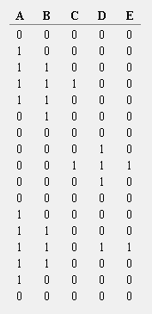

**Conclusion**

<small summary of key issues you ran into and your general design process>